Final Submission 1
Andy Hoang
Citlally Vasquez
Darrel Dennis
Max Ju
Troy Waters
Wai Soltow
Milestone 2 Written Report
Interview Analysis and Key Insights:
The following key insights come from a total of 17 interviews. Each key insight features a bar graph describing frequently discussed topics and how often they occurred within these 17 interviews.

Key Insight: Reliance On Word of Mouth and/or Pure Luck:
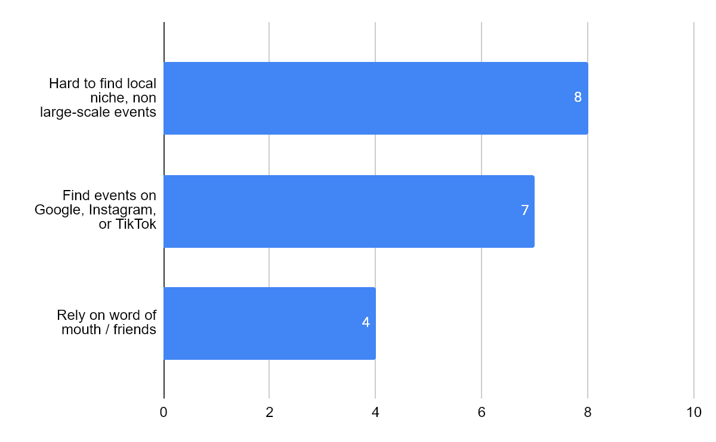
Interviewee’s explicitly mention having to rely on friends or even their own family members (spouses) to inform them of local events. While others may happily browse and explore the internet to find what’s happening locally, they feel they waste too much time and energy. At times, they felt frustrated since their searches can feel futile, especially given if they’re not even sure if they’re searching in the right place to begin with. Should they push through and continue searching, they are only punished by the algorithm. The irony in continuing their search is that they have now left behind a search history - ripe for data collection. Intentionally ignoring the security concern here to address another issue: advertisements and content generated based on their actions. A quick zoom out of the situation shows the larger picture: a feedback loop. Should a user ‘miss’ the target, they can continue to miss exponentially as content is shifted and mis-clicks can lead to redirection for the sake of websites trying to show sponsored content or even their biases. Now combine this with the issue of living in a large city: every single major corporation is fighting for your attention, to get you to go to their events. How exactly are you going to find what’s going on locally when you see the Staple Center is advertising their crypto arena convention this upcoming weekend? Many, for the sake of their sanity, have chosen the stance "the best move is not to play.”

Key Insight: Fragmented Communities and Oversaturation:
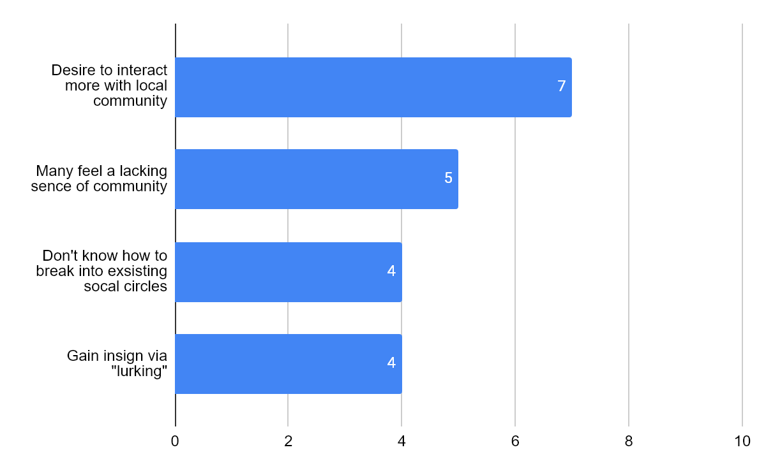

Users who lean more towards the extroverted nature find existing applications to fall short of what they desire. A common issue is “where do I go to tell others?” While users might be in existing Telegram group chats or Discord, there isn’t a singular location they go. This is governed by an uncontrollable variable - which is that everyone has their own preference, and they don’t want to budge. You can run into situations where a user has to copy-paste event planning discussions to multiple platforms to catch others up to speed or run the risk that some people will get left behind since they didn’t check the application they’re using to plan the event. A sort of “can someone tell [x] were planning an event?” Having to get everyone on the same page before the event is even finalized is a challenge in itself. A lot of times users want to skip that entirely - give them the event time and place, and they decide if they go or not.
Decision fatigue is a common theme distilled from the team’s interviews. One might not have guessed that asking the simple question “how do you keep ALL your friends up to date?” leads to the exhausting response of “I can’t.” Disregarding the individual philosophies of the interviewees in regards to their preference over a centralized or decentralized social network - the fact is, a lot of the tools created by other platforms allow for users to completely disregard any communication outside of that. A commonly used term for this situation is known as an “echo chamber.” While being able to privately communicate with friends is an amazing feature, there seems to be a shift where over time, users on a social media platform will begin to form private groups - communicating only with those they know directly. This is not a feature that should be taken away. In fact, the reason why a lot of users choose this route is because of how volatile the internet can be: a minefield, to put it lightly. Fighting the algorithm is a behemoth of a task already, but there’s still more.

Key Insight: Constrained and/or Frustrated by the Tools of Existing Platforms:
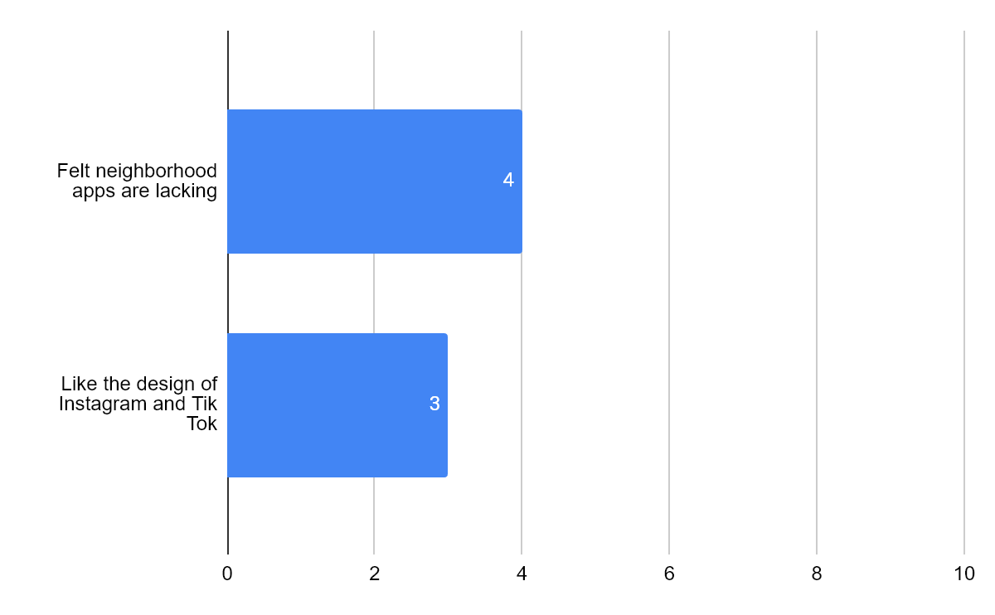
The individuals selected for interviews aren’t using pre-existing applications for local communication such as NextDoor. Many expressed frustration in that fact “nothing happens” when using such apps and that many people only use these apps only to complain and gossip. These users are seeking a way to actually create activities and get people together for events - not just text all day. There seems to be two common extremes: the first being users forced to engage with the platform, which can result in undesired consequences such as online hostility and users feeling unsafe to even initiate conversation. The second extreme is an application where users are so disengaged that the platform is dead on arrival. This can result in an application being so disconnected from reality that the user feels as if they’re wasting their time and begin their search for greener pastures.
It’s no secret then that social media apps focus heavily on having their users engage with their application. Notice how ‘engage’ by itself doesn’t actually mean anything when isolated - it’s just a verb. What this means is that the content the users engage with is irrelevant. For the major companies, this means limiting users to intentionally digging through endless material to find local events. During the interviews, people were asked about a particular feature - location based filtering. This one got a few eyebrow raises. The concept of being able to search for events based on distance meant they could find what they were looking for, and move on. This meant even smaller events could gain a spotlight, and that popularity alone was no longer a contest. Yet what we are left with are frustrated users who don’t have such a tool, because it goes against the focus and motivations of existing platforms.

Key Insight: Security and Privacy Concerns:
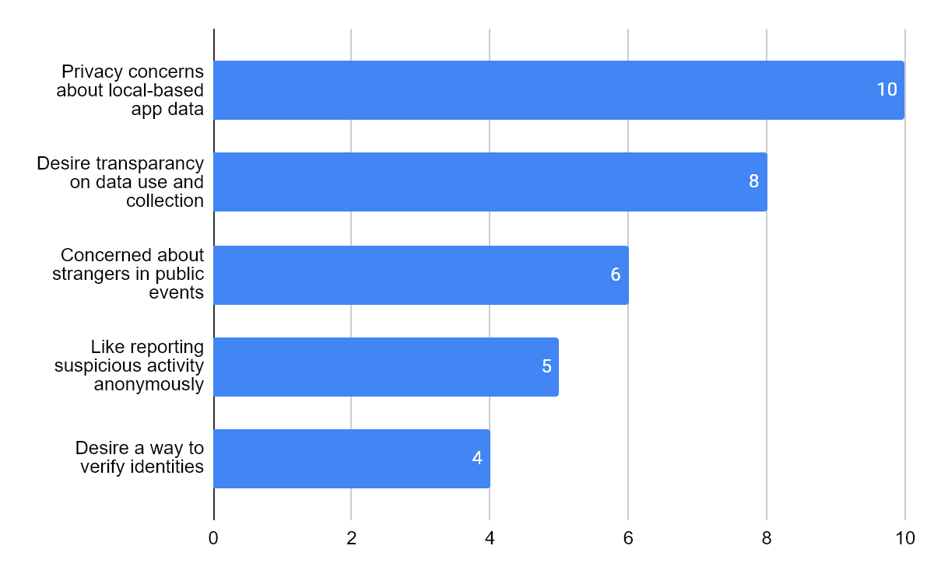
Nearly all interviewed were very much worried about how location is used in current applications, mentioning concerns with privacy on how their locations and interactions will be tracked or sold. The interviewees understand that locational data is necessary for certain applications to function, such as in Yelp or Google Maps, but value transparency on how such data is used. The preciseness of the tracking was one of many people's interests. Eight of the interviews were in strong support of more general locations being used, feeling that if precise locational data isn’t necessary for the task then it should not be used.
Upon the topic of safety, one of our key interests is making nearby public events more visible. People liked the idea of being able to quickly find events; but those interviewed, particularly women, expressed valid concerns about going to public events and how to gauge the safety of these posted events. They stated that they understand that anyone can post anything onto any social media website, even malicious actors, so ways to gauge safety would be greatly appreciated. Some methods include ways to gauge interest, the number of people attending via “likes”, the location of the event to see how publicly visible it is, and ways to verify if the event is legit.
Interviewees also discussed the safety of less tech savvy users and the content of these locational based forums. Those that mentioned it emphasized the need for transparency with user data and the use of warnings before any post is finalized, especially considering how one could accidentally send sensitive positional data. Those interviewed referenced the ability to report user generated content and a not-too restrictive filter on every post to prevent any obviously nefarious content seen on other social media platforms.

Key Insight: Preference for Intuitive Elements and Visuals:
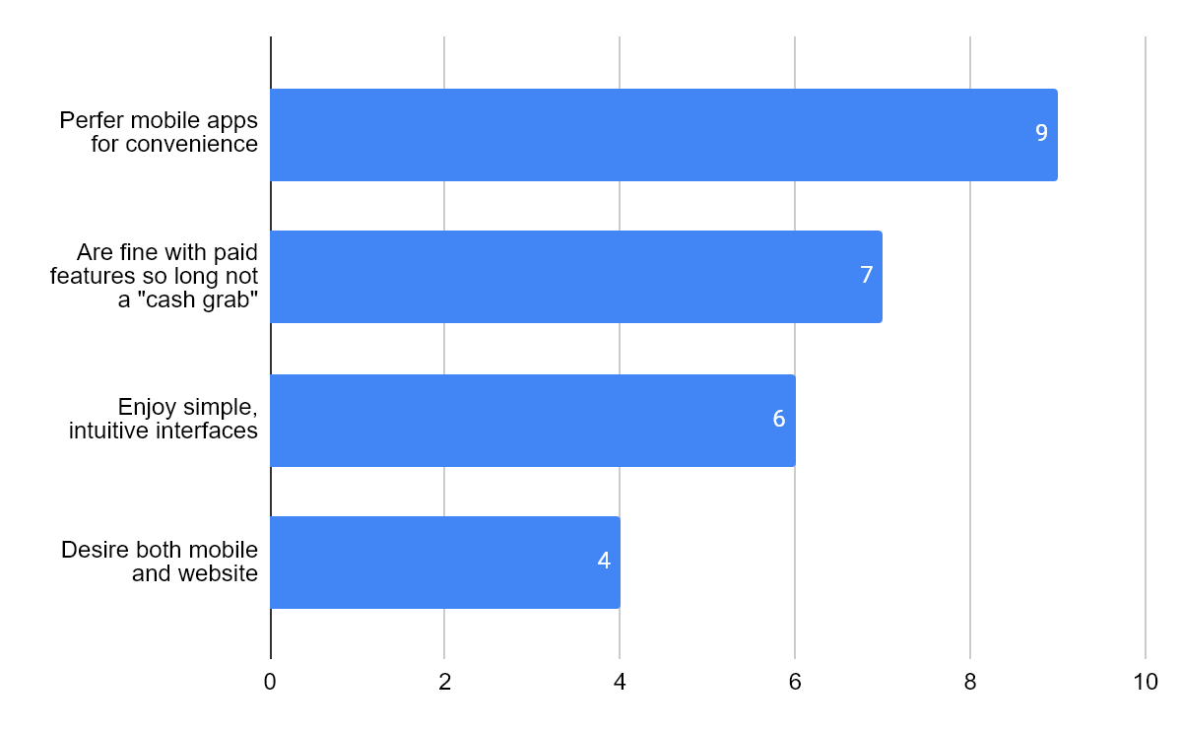
Images can speak a thousand words. While using sliders to filter events based on distance is something that has genuinely piqued the interest of our interviewees, any mention of a map or some visual cue was met with an immediate approval. Being able to see on a map that a hypothetical get-together is happening “Just east, a mile down,” from someone's current location would relieve much of the confusion in understanding directions and proximity. There would be no need of having to follow vague directions to a location you’ve never been to, like “Oh yeah, it’s down the street next to the Starbucks,” when there’s a dozen Starbucks on that street alone.
Given our culture in using platforms that incorporate location based visual aids such as Google Maps or Pokemon GO, people felt that implementing a similar feature would come intuitively and cause a lot less headache. One of the goals of our project is to streamline the hiccups that occur during event planning, namely deciding on a place to hang out. Being able to see real-time current events on a map is worth pivoting towards as we create the foundation for such a feature.
To further expand on this, interviewees made some interesting suggestions: being able to filter based on the event type, being able to click and see specific details, and even a number counter showing how many people are attending. Regarding safety, users knowing that an event they will be attending would include a large number of people would lower personal risk since safety in numbers.

Developed Personas:
Persona 1: Liora Calm : The introverted listener:

Many of us find value in listening, and Liora has learned a lot from listening first before doing. At 31 years of age, they are a loving parent of 3 who finds value in patience and thinking things through before acting. When she’s not at work or taking care of her children, she spends her time at home, catching up on her hobby: reading. On her days off, while her husband is at work, and her children are away at school, Liora finds herself with lots of free time.
Although she’s perfectly content with reading alone, she feels lonely without someone to confide in about her reading – someone to discuss plot points or certain scenes about. What she needs is a book club, one preferably close by. Although she likely won’t add much to the conversation, she’d prefer to just listen to whatever discourse they have on whatever books they’re reading. It can also serve as a way for Liora to get recommendations on what titles she can read next.

Persona 2: David Jones : The event planner:
David is a seasoned event planner who strives to bring joy to his clients and ensure they have the time of their lives at their events. He works hard to make sure that all party services are scheduled correctly and that the client’s needs are met. As a grandfather to 3 young grandchildren, David wants to plan community events so that his grandchildren, and many others, can enjoy their time together and have fun. Throughout his career he has stuck to pen-and-paper and is not familiar with technology since his children usually help him with tech heavy tasks.
Although David is confident in his planning skills, he is not sure how he will reach out to others in the community since most of his events are in a controlled (invite-only) environment. Platforms like Twitter and Reddit are a no-go, as David doesn’t have much of a personal following so no one would see his posts. The only social media platform he is familiar with is Facebook, but he mostly uses it to keep in touch with friends and family and wouldn’t know where to begin if he wanted to advertise an event on there. Furthermore, the only people he would be able to invite are his Facebook friends, mostly his colleagues and acquaintances all similar in age to him; not exactly the most ideal crowd for community-wide events.

Persona 3: Solana Knowles : The new, friendly University student:
When starting University, many of us find ourselves in a completely new environment with no connections. Solana, a new student, is entering the second week of her first semester and she has yet to make any acquaintances. In high school, she was very outgoing and felt comfortable with her friends. Now she attends class and asks her classmates for help when needed, but she feels as though their conversations are very surface level and she can’t quite get close to anyone.
One day, she overhears her classmates talking about the music club, and she gets inspired to join a club. Seeing as she’s a frequent online user, she starts to look for different clubs on instagram and eventually finds the movie club’s online chat. They have an event that will take place that same day and while Solana is excited to join the club, she is also nervous because she doesn’t know anyone from the club. Considering she has only seen people chat online, she doesn't know who they may be behind the screen or if they have good intentions.

Persona 4: Jordan “Jay” Martinez : The extroverted, loose cannon:

Extroverts are not the type to revel in cabin fever. Jay is no exception to this, he’s a 28 year old engineering major who absolutely loves getting out on the weekend. World is tough, and living in his own studio apartment has given him a lot of freedom - yet when you live alone and don’t know a lot of folk, it makes Jay even more eccentric - and everything becomes a new adventure for him.
However, that sentiment is not always shared. Time and time again he’s tried to plan events through messaging online friends, only to find they’re not interested in going out. Finding others who share both his interest and out-going energy is extremely difficult. The time and energy spent searching and searching for online communities isn’t helping either. You have to already know people to get invited to the Telegram chats for niche hobbies. He would have never guessed there’s a private Dance Dance Revolution group on telegram that plans out excursions to the Round 1 Arcade for round robin dancing. He has to rely mostly on Telegram since the nature of the application allows for more personalized discussion with others without the overhead of his identity being exposed. He feels more at ease expressing his true self in this environment, and loves sending personal photos of his excursions without telling the whole world about it. He prefers to keep it local. Trying to go to the arcade with someone on the other side of the world is a tad difficult, and there’s something meaningful when they’re right in front of you. For Jay, face-to-face conversation will never go out of style, and finds the hassle of endlessly messaging people on popular platforms to be quite the chore. Jay has also grown exhausted of having to constantly deal with miscommunication issues in online discussions, since his more eccentric nature can result in people misreading his sarcasm as hostility: an issue he doesn’t have when socializing in-person. He’s a simple person - he wants to let everyone know he’s going somewhere and if they wanna tag along, and that’s it. Instead of chasing others, keeping accountability, he just wants to socialize with others. In fact, the thrill of meeting new people who willingly travel to hang out and enjoy similar interests with Jay is what motivates him to keep going.

Use Case Scenarios:
Use Case 1: Last Minute Friday Plans
Jay just got off work - it’s 5pm, he just got home, and he has no plans. He’s only got one thing in mind: getting out. Jay decides to open up the application and sees a pin on the map: a Dave and Busters barcade meet-up right down the road. There’s already 10 people saying they’re going. Jay drops a message saying he’s also going, and dashes out the door. He double checks the pin since he’s rushing - he notices they left a photo with a comment stating “we're meeting in this spot right outside the barcade.” It doesn’t take long for Jay to arrive, and notices a couple folk right in the exact location. Fast forward 5 hours later and Jay crashes in his bed. He cracks a smile - he managed to let go of the stress of a long work week and had an awesome time chatting up strangers. He never expected someone to finally beat him at the basketball arcade machine, but he doesn’t mind. He went from a Friday night with no direction to an amazing night of making new friends.

Use Case 2: User goes on Vacation, has no plans, and wants to mingle with locals:
Liora has just gone on vacation with her family, opting to go to sunny Orlando, Florida. The trip is mostly for her kids, since they get to visit Disney World for the first time, but she and her husband have set aside some time on the vacation all to themselves. After a hectic week of packing, flying over, and spending a few days in Florida, Liora’s husband reveals that he had forgotten to make any plans for their alone time on the vacation. Disappointed, but not to be dismayed, Liora checks the website and looks for things that they can do while they’re in the area and finds a bar that’s holding a trivia night later that day. This lets Liora salvage her alone time with her husband, while also letting her showcase her book trivia knowledge--although it’ll be her husband doing all the talking.

Use Case 3: User lurks, notices something going on outside, and reports about it
Boredom strikes, and while Liora isn’t interested in going out, she still finds fun “lurking” in the application. She’s mindlessly scrolling through various discussions: people posting pictures of their time in the dog park, some strangers arguing about their favorite characters in a particular novel series. But then, she hears noises - fireworks, specifically. While it’s not an immediate danger, she throws up a discussion in her local area asking others about it. Replies come in - others saying they also hear it, and how they’re confused. But then an individual mentions someone is having a birthday party. While it’s a bit of an eye roller when someone is shooting fireworks on a Tuesday, it is a relief knowing it’s nothing serious. She safely goes back to lurking without being forced to engage with others socially about it, and continues reading a discussion thread about a book she’s reading.

Use Case 4: Safety in numbers: Staying home due to Low attendance
Solana Knowles threw an event up 3 days ago wondering if anyone wanted to attend a new movie that just got released. It’s nothing special - since most of the time will be spent watching the movie, she just thought it would be awesome to go out to a restaurant to talk about the movie with others right afterwards. However, as the event is coming close to starting - she notices only one other person wants to go. While the application encourages people to talk to locals, she’s decided out of her own safety to stay home. She mentions in the event chat she doesn’t feel comfortable and won’t be attending - and simply closes the application. The neat part is it’ll self-destruct by tomorrow and the event will no longer show up in the application. Given she was also anonymous she doesn’t have to concern herself with being bullied about the situation. In fact, she’s already thinking of posting the event again next week in hopes for more traction. End of the day, she gets to remain home safe and sound.

Use Case 5: Spontaneous movie plans
It’s Thursday and Solana’s professor just cancelled class, leaving her with one more hour to her day. She didn’t have anything planned but as she walked past a group of friends laughing out loud, she felt motivated to create connections, especially as a new student. She opened up the website and noticed that 6 people were all talking about the newest movie “Captain America: Brave New World”. Solana’s always been a fan of superhero movies and wanted to meet new people, so she asked if anyone wanted to see the movie that day. Three out of the six immediately responded and said they were down to go watch it, while the others were busy with other commitments. She was excited to go watch the new movie, but she was also nervous because she wasn’t sure if they were also university students or possibly a group of older men. However, she played it smart: she made sure the event took place in a populated movie theater during the day. She even mentioned when she created the event that she’s going to be on guard in case of any creeps. Her preparation for the situation leaves her at ease, and heads out - deciding it’s worth the risk in her journey to make more friends.

Use Case 6: Organizing a community fun day at the park
David wants to plan a weekend fun day at the park for his community so that his grandchildren and many others can enjoy their time together and have lots of fun. But, in order for him to plan a successful event, he needs to communicate with his community, which he has trouble with due to his lack of experience in technology. He is someone who has always used pen-and-paper throughout his career as a seasoned event planner. With the help of his children, he is able to organize the event through the app. He created the event, posted it on the community board, and promoted it to those around the local community. Soon after, many people from around the community showed interest in joining the Saturday fun day event at the park, with some even offering help to make it even better. In the coming weeks leading up to the event, he was able to send reminders, post updates, and even respond to those who had questions about the event. When the day finally came, the park was filled with excited families. The kids were all having fun playing games, parents were enjoying their time, and David was proud to see how it all turned out.

INSTRUCTIONS - Don't write here!
========================================================
[Final] INSTRUCTIONS:

DO NOT WRITE HERE, ON NEXT TAB

(Darrel: DO NOT WRITE HERE, JUST TO CHECK PAGE COUNT FOR NOW!!!)

Compile the following a single report:
Part 1 : Interview Analysis (~7 pages)
Part 2: Persona Development (~ 4 pages)
Part 3: Use Case Scenarios (~4 pages)





